Amines / Nitriles /Amides
a) Draw the structures for

(i) ethanamine

(ii) ethanamide

(iii) propanenitrile

(iv) 5,N-dimethylhexanamide

(v) diethylamine

(vi) 2-aminobutanenitrile

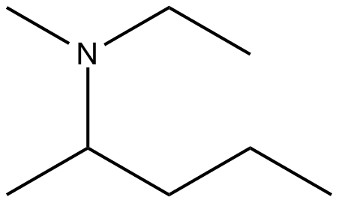
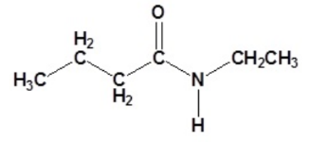
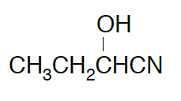
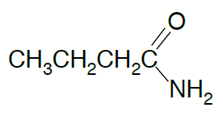
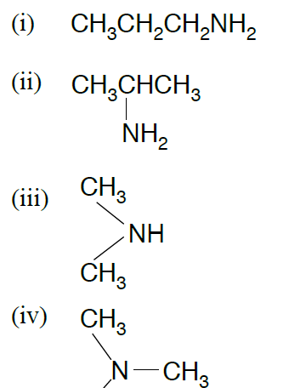
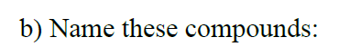
(v)

(vi)

